-- Create Database

create DATABASE ICE_9th_batch;

USE ICE_9th_batch;

-- Create Table

create table STUDENT_DATA(

name varchar(50),

roll int(30),

session varchar(30),

course varchar(30));

-- Insert Value

INSERT INTO STUDENT_DATA(name,roll,session,course) VALUES('Shifa',39,'2020-21','DC');

INSERT INTO STUDENT_DATA(name,roll,session,course) VALUES('Jemi',40,'2020-21','ITF');

INSERT INTO STUDENT_DATA(name,roll,session,course) VALUES('Jarir',01,'2020-21','DC');

INSERT INTO STUDENT_DATA(name,roll,session,course) VALUES('Jarir',02,'2020-21','IPE');

INSERT INTO STUDENT_DATA(name,roll,session,course) VALUES('Jarir',03,'2020-21','DBMS');

-- Show Data From Table

select * From STUDENT_DATA;

select * from STUDENT_DATA where roll =01;

select * from STUDENT_DATA where name='Shifa';

select * from STUDENT_DATA where session='2020-21';

select Distinct name from STUDENT_DATA;

select roll from STUDENT_DATA order by roll asc;

select roll from STUDENT_DATA order by roll desc;

select roll from STUDENT_DATA where roll=03;

select * from STUDENT_DATA where name='Jarir' AND roll=03 ;

select * from STUDENT_DATA where name='Jarir' or roll=03 ;

alter table STUDENT_DATA ADD column dept varchar(30);

alter table STUDENT_DATA Drop column dept;

alter table STUDENT_DATA Rename column roll to id;

alter table STUDENT_DATA Modify roll float(30);

UPDATE STUDENT_DATA SET id= 10 WHERE id=1;

delete from STUDENT_DATA where name='Shifa';

-- Destroy Table

DROP TABLE STUDENT_DATA ;

-- Drop Database

DROP DATABASE ICE_9th_batch;

-- Create Database

create DATABASE ICE_9th_batch;



USE ICE_9th_batch;

-- Create Table

create table STUDENT_DATA(

name varchar(50),

roll int(30),

session varchar(30),

course varchar(30));



-- Insert Value

INSERT INTO STUDENT_DATA(name,roll,session,course) VALUES('Shifa',39,'2020-21','DC');

INSERT INTO STUDENT_DATA(name,roll,session,course) VALUES('Jemi',40,'2020-21','ITF');

INSERT INTO STUDENT_DATA(name,roll,session,course) VALUES('Jarir',01,'2020-21','DC');

INSERT INTO STUDENT_DATA(name,roll,session,course) VALUES('Jarir',02,'2020-21','IPE');

INSERT INTO STUDENT_DATA(name,roll,session,course) VALUES('Jarir',03,'2020-21','DBMS');

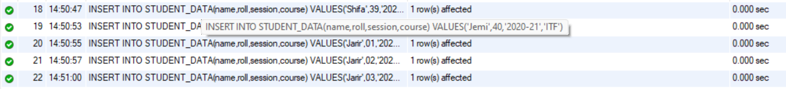

-- Show Data From Table

select * From STUDENT_DATA;

select * from STUDENT_DATA where roll =01;

select * from STUDENT_DATA where name='Shifa';

select * from STUDENT_DATA where session='2020-21';



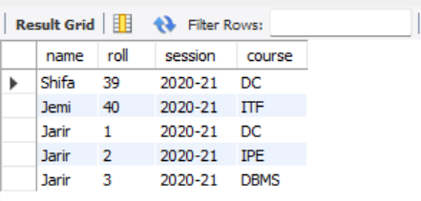 select * From STUDENT_DATA;

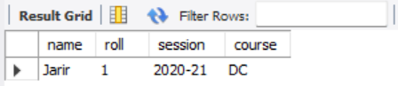 select * from STUDENT_DATA where roll =01;

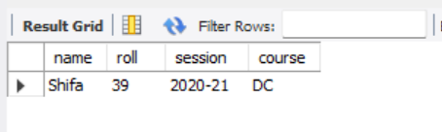 select * from STUDENT_DATA where name='Shifa';

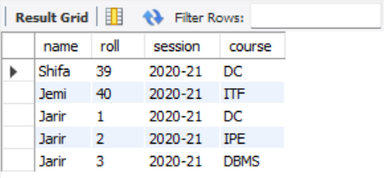 select * from STUDENT_DATA where session='2020-21';

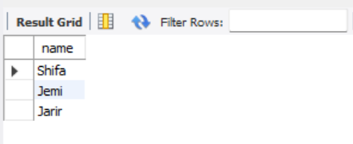 select Distinct name from STUDENT_DATA;

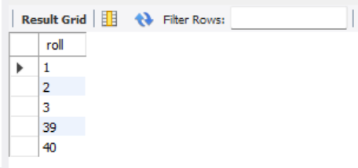 select roll from STUDENT_DATA order by roll asc;

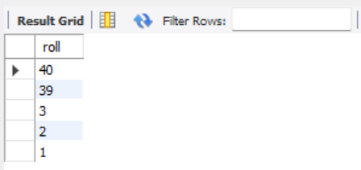 select roll from STUDENT_DATA order by roll desc;

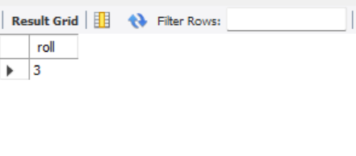 select roll from STUDENT_DATA where roll=03;

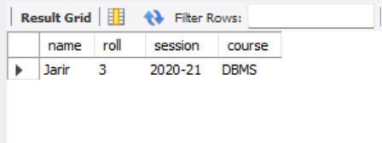 select * from STUDENT_DATA where name='Jarir' AND roll=03 ;

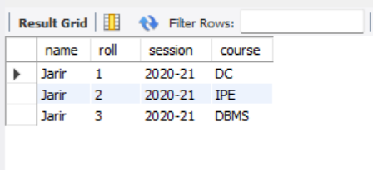 select * from STUDENT_DATA where name='Jarir' or roll=03 ;

alter table STUDENT_DATA ADD column dept varchar(30);



BEFORE:



AFTER:

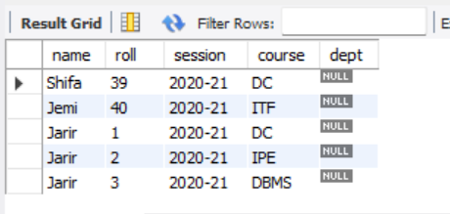

alter table STUDENT_DATA Drop column dept;



BEFORE:



AFTER:

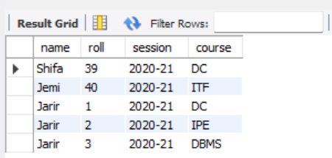

alter table STUDENT_DATA Rename column roll to id;



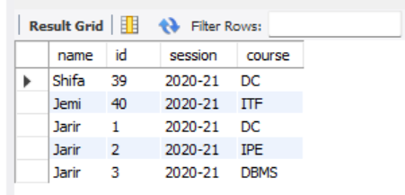

alter table STUDENT_DATA Modify roll float(30);



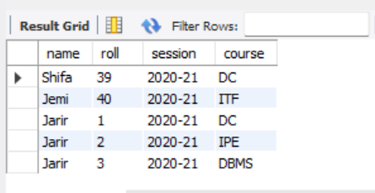

UPDATE STUDENT_DATA SET id= 10 WHERE id=1;



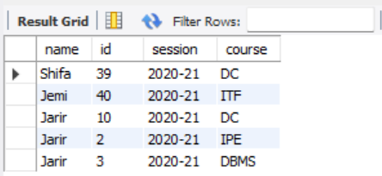

delete from STUDENT_DATA where name='Shifa';



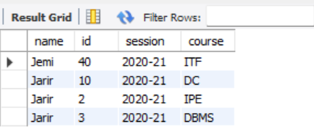

-- Destroy Table

DROP TABLE STUDENT_DATA ;



-- Drop Database

DROP DATABASE ICE_9th_batch;



create database java;

use java;

create table employee(

id int(50),

age int(30),

first varchar(30),

last varchar(30));

INSERT INTO Registration VALUES (100, 'Zara', 'Ali', 18);

INSERT INTO Registration VALUES (101, 'Mahnaz', 'Fatma', 25);

INSERT INTO Registration VALUES (102, 'Zaid', 'Khan', 30);

INSERT INTO Registration VALUES(103, 'Sumit', 'Mittal', 28);